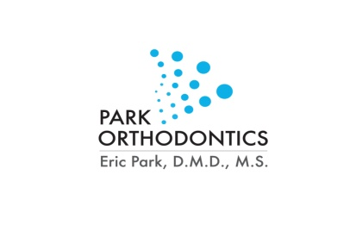
Park Orthodontics, P.C. 4935 Stewart Mill Road, Suite 200 Douglasville, GA 30135
Eric P. Park, D.M.D, M.S. P: 770-627-3042 F: 770-627-3243 www.drparkortho.com

Agreement to Receive Electronic Communication

Patient Name: ______________________________________ Date of Birth:_______________

I agree that the dental practice may communicate with me electronically at the email address below.

I am aware that there is some level of risk that third parties might be able to read unencrypted emails.

I am responsible for providing the dental practice any updates to my email address.

I can withdraw my consent to electronic communications by calling:

770-627-3042

Email Address (PLEASE PRINT CLEARLY):

__________________________________________________@__________________________

Patient/Responsible Party Signature:____________________________________________

Date:________________________

Reproduction of this material by dentists and their staff is permitted. Any other use, duplication or distribution by any other party requires the prior written approval ofthe American Dental Association. This material is for general reference purposes only and does not constitute legal advice. It covers only HIPAA ,not otherfederal or state law. Changes in applicable laws or regulations may require revision. Dentists should contact qualified legal counsel for legal advice,including advice pertaining to HIPAA compliance, the HITEC H Act, and the U.S. Department of Health and Human Services rules and regulations.

© 2010, 2013 American Dental Association. All Rights Reserved.

